**2016 *FIRST* LEGO® League State Championship T-Shirt Order Form**

**$10.00 Each**

These tournament shirts are a great remembrance of the day. A list of the *FIRST***®** LEGO**®** League teams and *FIRST***®** LEGO**®** League Jr. teams attending the event will be on the back.

**Please submit one order form per team. Remember to offer the shirts to all team members, coaches and parents.**

**All shirt orders are due on or before January 19, 2015. Please return the form to Kelli Dubendorfer. You can e-mail it to kelli.dubendorfer.ctr@us.af.mil; fax it to (937) 904-8033.**

We understand this is a quick turnaround. If you are not able to do the pre-order by this date, there will be t-shirts for sale at the Nutter Center during the tournament weekend. **We strongly recommend a pre-order since there will be a limited number of shirts available the day of the event.**

The shirts will be available for you to pick up on the day of the event. **Total payment by check (made out to the Ohio Educational Outreach Foundation) or cash (please have exact amount in an envelope) can be made when you pick up the shirts on the day of the event.**

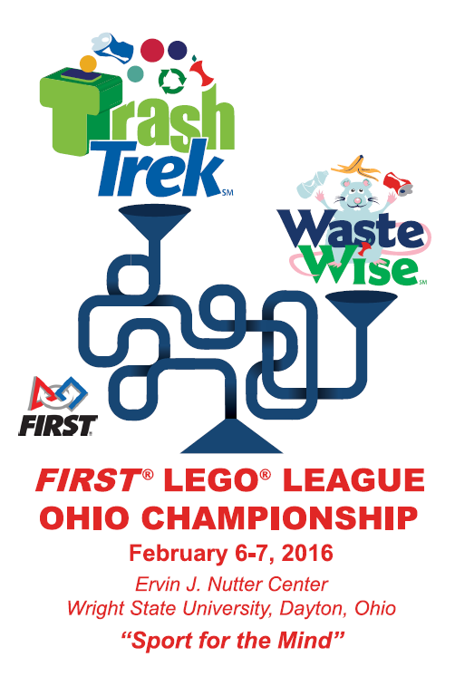**Team Number: ______17361** **__________**

**Team Name: __________BlockBusters___________________**

**Coaches Names: _____Louis Pochet Mike Noyola_______________**

|  |  |  |  |
| --- | --- | --- | --- |
| **Youth** | **Number** | **Adult** | **Number** |
| Small |  | Small | **1** |
| Medium | 7 | Medium | **2** |
| Large | **4** | Large | **1** |
| XL |  | XL | **2** |
|  |  | 2XL-5XL | Size: #: |
|  |  | **Total** | **17** |
|  |  |  | **X $10.00** |
|  |  | **Total Cost** | **170** |

**Design**

**\*\*Shirts will be gray\*\***